**Vehicle Standby Limitation**

***Work-flow to Use Vehicle Standby Limitation***

The Vehicle Standby Limitation preference is accessed through **Load Template** and only one instance of it is permitted.

***Preference Overview***

The Vehicle Standby Limitation preference sets a continues vehicle standby time range for which vehicles may not be in use.

It can be set as a constraint or as a preference using a penalty for a standby duration outside of the range.

***Templates Available from Optibus***

***Vehicle standby limitation***

**Purpose:**

Sets the standby period for  **max continues vehicle standby time.**

**Prerequisites:** None.

**Opening Dialog:**

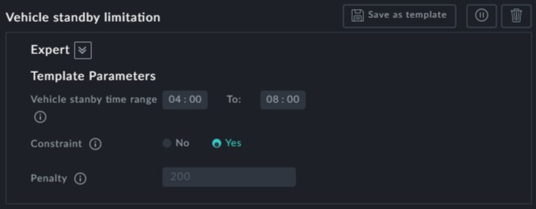

**Points to note:**

**Vehicle standby time range**:

**Specify the time range for max continues vehicle standby time.**

**Constraint**: The upper limit of the standby time range can be made a constraint by

setting **Constraint** to Yes.

**Penalty**: The penalty will be imposed inside the specified time range (the lower time range limit gets 0 penalty, the upper time range limit gets full penalty.

Only one instance of this template may be used